ព្រះរាជាណាចក្រកម្ពុជា

ជាតិ​ សាសនា ព្រះមហាក្សត្រ

Institute of technology of Cambodia

Department of Information and communication Engineering

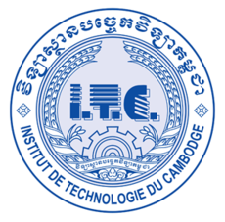

The lesson taking about using recursive function in c++

TP13 Recursive function

TP: Algorithm and Programming ll

Lecturer: BOU CHANNA

Student: VEN THON

ID: e20191250

Group: I3-GIC-C

Year: 2022-2023

# Problem1:

A C++program that can perform various mathematic operations below.Solve each operation using recursive operation.a.A power function to calculate

mn.It is mmultiply mfor n times(m*m*...*m)int power(int m, int n)

b.A function to calculate sum of square of first n integer 12+22+...+n2.int sumSquare(int n)

c.Sumthe digits of a number.int sumDigit(int n)

